**Simply apply**

# CHAPTER 1 PROJECT PROPOSAL

## Introduction

According to the survey, most of the students studying in different colleges and schools of Abbottabad belong to rural areas which are far away from the desired places of study which is a problem for students because they are compelled to travel a long way to take admission and do other processes. so we have decided to build software that can bring ease for students to complete their admission process along with other primary processes through this software.

## Vision and Business Case

In this project, there is a section named owner, which will be overall controlled by the institutes that provide admission for students and will allow students to access their institute’s information for primary processes. Later on, we have Student section in which students can search for their desired schools and colleges and access their information regarding the admission processes and also they can take admission in that desired institute. With this, there is also a section of visitors through which users can visit the website and check about different institutes present inside this software.

**USE case of Project Diagram:**

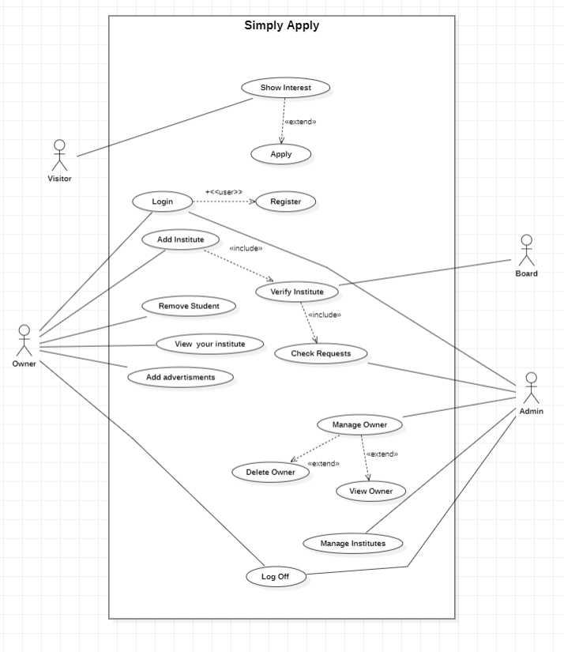

**SSD Diagram**

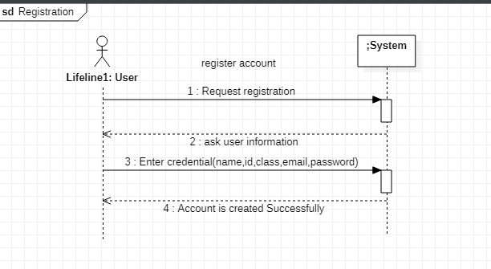

#### **Contract Operation**

#### Use Case UC1: register account

**Contract ID**: Request Registration

**Operation:** Request Registration ()

**Cross References:** Use cases: Register account

**Pre-conditions:**

* User is not registered.
* The System is running correctly.­­

**Post-conditions:­­**

* User is registered and Account is created successfully.

**Contract ID**: Enter Credential

**Operation:** Enter information ()

**Cross References:** Use cases: Register account

**Pre-conditions:**

* User is not registered.
* The System is running correctly.
* All enter information should be in proper valid form.

**Post-conditions:**

* User is registered and Account is created successfully.

**USE Case Details**

## Shabbir Hussain (SP21-BSE-047)

**Use Case:**

Register Account

**Description:**

The use case describes how an owner can register their institute.

**Primary Actors:**

Companies, academics, and students

**Secondary Actors:**

None

**Preconditions:**

The institute registration web page is displayed to the owner. The institute is not registered

**Main success Scenario:**

* The use case starts when the user clicks the “Sign Up” tab on the navigation bar.
* The system displays the signup page that allow users to fill in their username/email address, first and last name and their password.
* The user keys in the details and clicks “Sign Up” button.
* The system displays the user’s profile page.

**Alternative Flow:**

* If the username is invalid, the owner is asked to choose another username.
* If owner enter incomplete details, system displays “please complete personal details” message.

**Post Conditions:**

Owner and institute registered .The grooming web page is displayed.

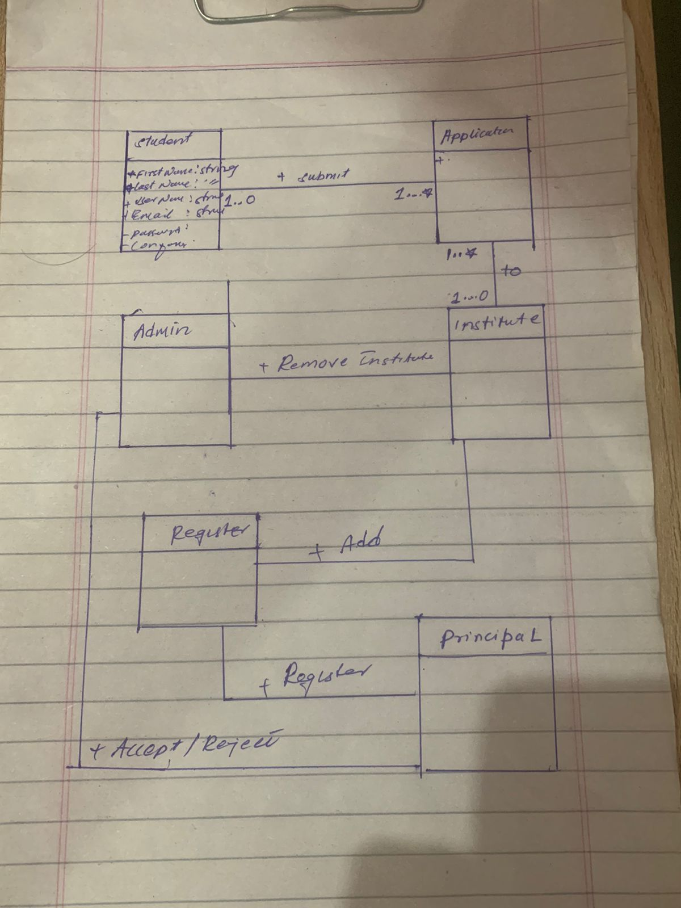**Domain Model Your Project**

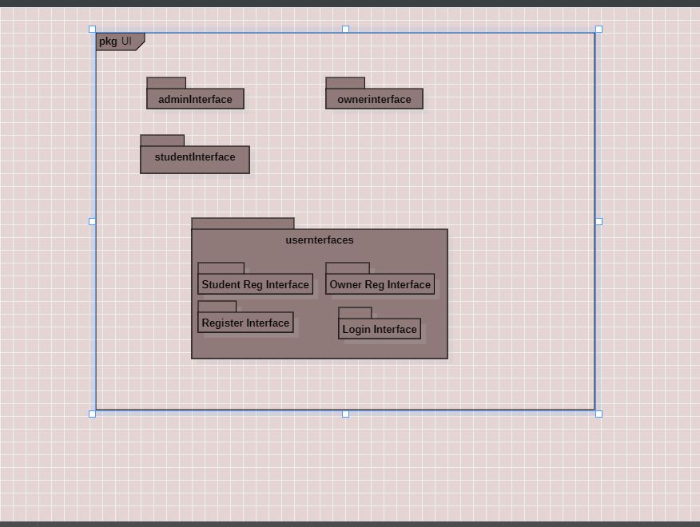**Package Diagram project**